OFFICIAL COORDINATION REQUEST
FOR
NON-ROUTINE OPERATIONS AND MAINTENANCE

COORDINATION DATE- 09 June 2010
PROJECT- Bonneville
RESPONSE DATE- 23 June 2010

Description of the problem
The Bonneville Spillway Gate Pit Repair Clean-up and Shoring project requires work on the east and west walls of the gate repair pit and the gate storage pit, which is located adjacent to the Cascades Island fish ladder. A detailed description of the work is in an attachment completed by the contractor. Here is an overview description:

1. Construct additional concrete grade beams adjacent to the existing grade beams. This will involve installing reinforcing steel, and roughening up and placing concrete. This includes:
- Inserting rebar into existing grade beam on the north side of the east and west walls of the gate repair pit, within 50’ of the Cascades Island fish ladder.
- Work will also be done in the south side of the gate storage pit, which is within 50’ of the fish elevator entrance area.
- Roughening up concrete throughout the length of the gate repair and gate storage pit prior to pouring concrete.

2. Drill and install anchor bolts into the existing grade beam, bridge girder, and intermediate wall flange and install vertical support columns consisting of wide flange steel beams between the bridge girder and grade beam. This includes:
- 16 columns total in the pit, with 6 vertical support columns within 50' of the fishway towards the north end of the gate repair pit, and two vertical support columns at the south end of the gate repair.

The contractor has the shoring work schedule for 6 July until 31 August. Currently the contractor plans on drilling close to the fishway in early July, when fewer salmonids and lamprey are migrating as shown in the figure below. Noise generating activity will be restricted to 2200-0430.
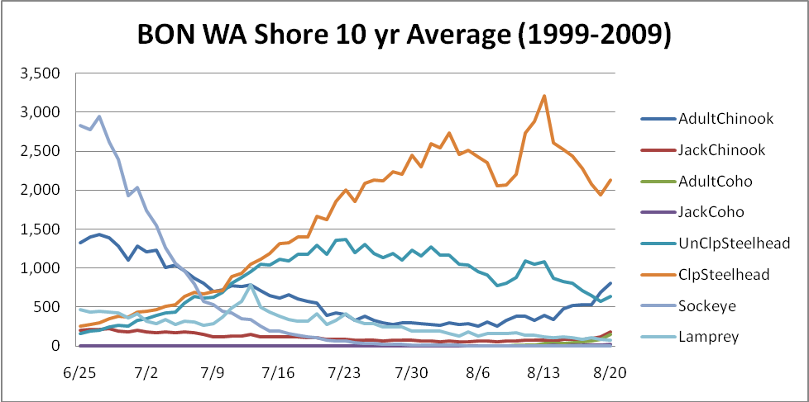
Type of outage required
No outage required.

Impact on facility operation
Potential to impact migrating adults in the Cascades Island ladder.

Length of time for repairs
The schedule the Contractor provided showed the shoring work taking place over a period of about 56 calendar days from 06 July until 31 August (this includes the concrete grade beams, anchor bolts, vertical columns, and lateral bracing). However, not all work is within 50’ of fishway.

Expected impacts on fish passage
Noise generating activity will occur within 50’ of the Cascades Island fishway, and has the potential to impact migrating fish. To minimize impacts, noise generating activities will be limited to 2200-0430, which falls within the nighttime hours listed in Table BON-5. Activity in the gate storage pit is expected to have minimal impact, as it is thought most fish head up the ladder and avoid the fish elevator entrance area. All of the activity is inside the gate repair pit and the gate storage pit, and the surrounding wall is approximately one foot of concrete.

Table BON-5. Daytime spill schedule for Bonneville Project.
Jun 01 – Jun 30 | 0430 | 2130
Jul 01 – Jul 31 | 0430 | 2200
Aug 01 – Aug 15 | 0500 | 2145
Aug 16 – Aug 31 | 0500 | 2030

Few salmonids tend to pass the fishway between 2000-0400 as shown by the diel graphs found at: http://www.nwp.usace.army.mil/op/fishdata/home.asp#firstbox under the Fishladder Diel (Across the Day) Passage Charts section. Lamprey passage increases from 1800-0600. See http://www.nwp.usace.army.mil/op/fishdata/docs/DielLamprey.pdf. However, a smaller proportion of adult lamprey approach Cascades Island entrance, as seen in the figure below from Clabough, et al, 2009, Evaluation of Adult Pacific Lamprey Passage at the Cascade Island fishway after entrance modification.

Comments from agencies

Final results

